MET CS 555 Assignment 1
Joseph Rissman
9/14/2024
- See R code pasted below.
- Here is the histogram generated in R.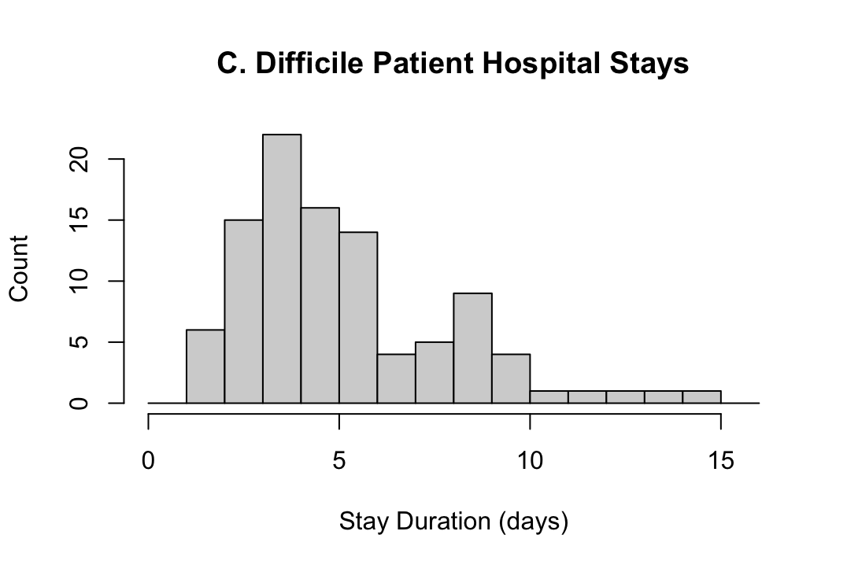
S: The data appears to be bimodal and right skewed.
O: There appear to be several outliers on the right tail of the data.
C: There appears to be two centers of the data, related to the bimodal shape. They are at 4 and 9 days.
S: The spread of bimodal data is harder to describe, but the interquartile range (IQR) is 3 days.
- Here is the summary statistics for the data.
Mean | Median | Standard Deviation | First Quartile | Third Quartile | Minimum | Maximum
5.63 | 5 | 2.74379 | 4 | 7 | 2 | 15
Given the shape of the distribution, the best single number summary of the center would be the median. The median is not impacted as strongly by outliers as the mean.
The best summary evaluation number of the distribution spread would be the interquartile range (IQR). The IQR is not impacted as strongly by outliers as the standard deviation.
- All calculations were done in R. See code pasted below.
  - Based on the normal distribution described in the literature, 90.9% of hospital stays are less than 10 days (meaning 9 days or less).
  - The probability that the sample mean is greater than 6 is 0.0243.

R code for Assignment 1
library(readxl)
library(dplyr)
library(tidyr)

# Problem 1-3 -------------------------------------------------------------

# Read hospital data from Excel file
data <- read_excel("Homework 1/Homework 1 Data.xlsx", col_names = FALSE)

# Reformat excel data into a single variable
data <- stack(data)$values

# Plot histogram
hist(data, breaks = seq(0, max(data) + 1, by = 1),
xlab = "Stay Duration (days)", ylab = "Count",
main = "C. Difficile Patient Hospital Stays")

# Calculate summary statistics
summary(data)
sd(data)

# Problem 4 ---------------------------------------------------------------
population_mean <- 5
population_sd <- 3
sample_size <- 35
standard_error <- population_sd/sqrt(sample_size)

# Probability that duration is less than 10 days (P[X =< 9])
pnorm(9, mean = population_mean, sd = population_sd)

# Probability that sample mean is greater than 6 days (P[X > 6])
pnorm(6, mean = population_mean, sd = standard_error, lower.tail = FALSE)

